Table of Contents

TABLE OF FIGURES 3

LSTM (baseline for comparison) 8

Result of Full Features 8

Result of Filtered Features 8

PatchTST (baseline for comparison) 8

Result of Full Features 8

Result of Filtered Features 8

iTransformer (baseline for comparison) 9

Result of Full Features 9

Result of Filtered Features 9

LSTM + Vietnamese Embedding 9

Results 9

Cross-Attention Fusion 9

Concatenate Fusion 11

LSTM + Vietnamese Document Embedding 13

Results 13

Cross-Attention 13

Concatenate Fusion 15

PatchTST + Vietnamese Embedding 17

Results 17

Cross-Attention 17

Concatenate Fusion 19

PatchTST + Vietnamese Document Embedding 21

Results 21

Cross-Attention 21

Concatenate Fusion 23

iTransformer + Vietnamese Embedding 25

Results 25

Cross-Attention 25

Concatenate Fusion 27

iTransformer + Vietnamese Document Embedding 29

Results 29

Cross-Attention 29

Concatenate Fusion 31

# TABLE OF FIGURES

Figure 1: Test Set Results of LSTM Full Features 8

Figure 2: Test Set Results of LSTM Filtered Features 8

Figure 3: Test Set Results of PatchTST Full Features 8

Figure 4: Test Set Results of PatchTST Filtered Features 8

Figure 5: Test Set Results of iTransFormer Full Features 9

Figure 6: Test Set Results of iTransFormer Filtered Features 9

Figure 7: Validation Loss by Window Size and Training Curves of LSTM_VN_Emb_CrsAtt 9

Figure 8: Test Set Results of LSTM_VN_Emb_CrsAtt 9

Figure 9: Actual vs predicted closing prices (LSTM_VN_Emb_CrsAtt) across multiple forecasting horizons (H = 1, 4, 7) 10

Figure 10: Actual vs predicted closing prices on (LSTM_VN_Emb_CrsAtt) across multiple forecasting horizons (H = 10, 14, 21) 10

Figure 11: Multi-horizon stock price prediction on a test sample (LSTM_VN_Emb_CrsAtt) 11

Figure 12: Validation Loss by Window Size and Training Curves of LSTM_VN_Emb_Concat 11

Figure 13: Test Set Results of LSTM_VN_Emb_Concat 11

Figure 14: Actual vs predicted closing prices (LSTM_VN_Emb_Concat) across multiple forecasting horizons (H = 1, 4, 7) 12

Figure 15: Actual vs predicted closing prices (LSTM_VN_Emb_Concat) across multiple forecasting horizons (H = 10, 14, 21) 12

Figure 16: Multi-horizon stock price prediction on a test sample (LSTM_VN_Emb_ConCat) 13

Figure 17: Validation Loss by Window Size and Training Curves of LSTM_VN_Doc_Emb_CrsAtt 13

Figure 18: Test Set Results of LSTM_VN_Doc_Emb_CrsAtt 13

Figure 19: Actual vs predicted closing prices (LSTM_VN_Emb_Doc_CrsAtt) across multiple forecasting horizons (H = 1, 4, 7) 14

Figure 20: Actual vs predicted closing prices (LSTM_VN_Emb_Doc_CrsAtt) across multiple forecasting horizons (H=10,14,21) 14

Figure 21: Multi-horizon stock price prediction on a test sample (LSTM_VN_Doc_Emb_CrsAtt) 15

Figure 22: Validation Loss by Window Size and Training Curves of LSTM_VN_Doc_Emb_Concat 15

Figure 23: Test Set Results of LSTM_VN_Doc_Emb_Concat 15

Figure 24: Actual vs predicted closing prices (LSTM_VN_Emb_Doc_Concat) across multiple forecasting horizons (H = 1, 4, 7) 16

Figure 25: Actual vs predicted closing prices (LSTM_VN_Emb_Doc_Concat) across multiple forecasting horizons (H=10,14,21) 16

Figure 26: Multi-horizon stock price prediction on a test sample (LSTM_VN_Doc_Emb_Concat) 17

Figure 27: Validation Loss by Window Size and Training Curves of PatchTST_VN_Emb_CrsAtt 17

Figure 28: Test Set Results of PatchTST_VN_Emb_CrsAtt 17

Figure 29: Actual vs predicted closing prices (PatchTST_VN_Emb_CrsAtt) across multiple forecasting horizons (H=1,4,7) 18

Figure 30: Actual vs predicted closing prices (PatchTST_VN_Emb_CrsAtt) across multiple forecasting horizons (H=10,14,21) 18

Figure 31: Multi-horizon stock price prediction on a test sample (PatchTST_VN_Emb_CrsAtt) 19

Figure 32: Validation Loss by Window Size and Training Curves of PatchTST_VN_Emb_Concat 19

Figure 33: Test Set Results of PatchTST_VN_Emb_Concat 19

Figure 34: Actual vs predicted closing prices (PatchTST_VN_Emb_Concat) across multiple forecasting horizons (H=1,4,7) 20

Figure 35: Actual vs predicted closing prices (PatchTST_VN_Emb_Concat) across multiple forecasting horizons (H=10,14,21) 20

Figure 36: Multi-horizon stock price prediction on a test sample (PatchTST_VN_Emb_Concat) 21

Figure 37: Validation Loss by Window Size and Training Curves of PatchTST_VN_Doc_Emb_CrsAtt 21

Figure 38: Test Set Results of PatchTST_VN_Doc_Emb_CrsAtt 21

Figure 39: Actual vs predicted closing prices (PatchTST_VN_Doc_Emb_CrsAtt) across multiple forecasting horizons (H=1,4,7) 22

Figure 40: Actual vs predicted closing prices (PatchTST_VN_Doc_Emb_CrsAtt) across multiple forecasting horizons (H=10,14,21) 22

Figure 41: Multi-horizon stock price prediction on a test sample (PatchTST_VN_Doc_Emb_CrsAtt) 23

Figure 42: Validation Loss by Window Size and Training Curves of PatchTST_VN_Doc_Emb_Concat 23

Figure 43: Test Set Results of PatchTST_VN_Doc_Emb_Concat 23

Figure 44: Actual vs predicted closing prices (PatchTST_VN_Doc_Emb_Concat) across multiple forecasting horizons (H=1,4,7) 24

Figure 45: Actual vs predicted closing prices (PatchTST_VN_Doc_Emb_Concat) across multiple forecasting horizons (H=10,14,21) 24

Figure 46: Multi-horizon stock price prediction on a test sample (PatchTST_VN_Doc_Emb_Concat) 25

Figure 47: Validation Loss by Window Size and Training Curves of iTransformer_VN_Emb_CrsAtt 25

Figure 48: Test Set Results of iTransformer_VN_Emb_CrsAtt 25

Figure 49: Actual vs predicted closing prices (iTransformer_VN_Emb_CrsAtt) across multiple forecasting horizons (H=1,4,7) 26

Figure 50: Actual vs predicted closing prices (iTransformer_VN_Emb_CrsAtt) across multiple forecasting horizons (H=10,14,21) 26

Figure 51: Multi-horizon stock price prediction on a test sample (iTransformer_VN_Emb_CrsAtt) 27

Figure 52: Validation Loss by Window Size and Training Curves of iTransformer_VN_Emb_Concat 27

Figure 53: Test Set Results of iTransformer_VN_Emb_Concat 27

Figure 54: Actual vs predicted closing prices (iTransformer_VN_Emb_Concat) across multiple forecasting horizons (H=1,4,7) 28

Figure 55: Actual vs predicted closing prices (iTransformer_VN_Emb_Concat) across multiple forecasting horizons (H=10,14,21) 28

Figure 56: Multi-horizon stock price prediction on a test sample (iTransformer_VN_Emb_Concat) 29

Figure 57: Validation Loss by Window Size and Training Curves of iTransformer_VN_Doc_Emb_CrsAtt 29

Figure 58: Test Set Results of iTransformer_VN_Doc_Emb_CrsAtt 29

Figure 59: Actual vs predicted closing prices (iTransformer_VN_Doc_Emb_CrsAtt) across multiple forecasting horizons (H=1,4,7) 30

Figure 60: Actual vs predicted closing prices (iTransformer_VN_Doc_Emb_CrsAtt) across multiple forecasting horizons (H=10,14,21) 30

Figure 61: Multi-horizon stock price prediction on a test sample (iTransformer_VN_Doc_Emb_CrsAtt) 31

Figure 62: Validation Loss by Window Size and Training Curves of iTransformer_VN_Doc_Emb_Concat 31

Figure 63: Test Set Results of iTransformer_VN_Doc_Emb_Concat 31

Figure 64: Actual vs predicted closing prices (iTransformer_VN_Doc_Emb_Concat) across multiple forecasting horizons (H=1,4,7) 32

Figure 65: Actual vs predicted closing prices (iTransformer_VN_Doc_Emb_Concat) across multiple forecasting horizons (H=10,14,21) 32

Figure 66: Multi-horizon stock price prediction on a test sample (iTransformer_VN_Doc_Emb_Concat) 33

# LSTM (baseline for comparison)

## Result of Full Features

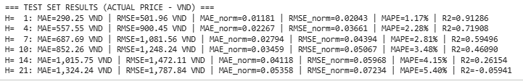

Figure 1: Test Set Results of LSTM Full Features

## Result of Filtered Features

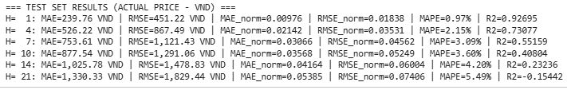

Figure 2: Test Set Results of LSTM Filtered Features

# PatchTST (baseline for comparison)

## Result of Full Features

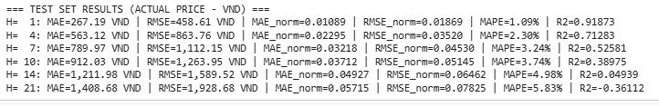

Figure 3: Test Set Results of PatchTST Full Features

## Result of Filtered Features

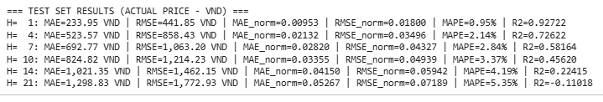

Figure 4: Test Set Results of PatchTST Filtered Features

# iTransformer (baseline for comparison)

## Result of Full Features

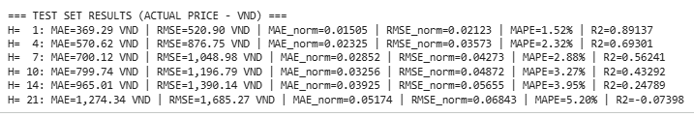

Figure 5: Test Set Results of iTransFormer Full Features

## Result of Filtered Features

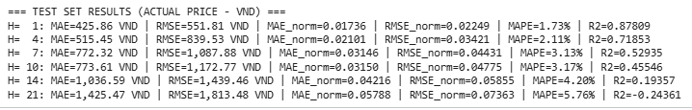

Figure 6: Test Set Results of iTransFormer Filtered Features

# LSTM + Vietnamese Embedding

## Results

### Cross-Attention Fusion

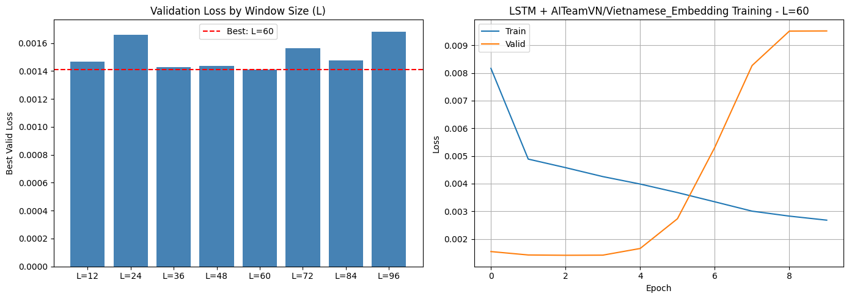

Figure 7: Validation Loss by Window Size and Training Curves of LSTM_VN_Emb_CrsAtt

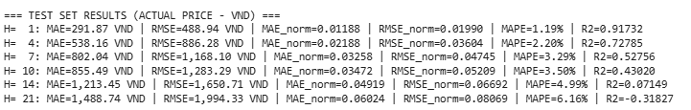

Figure 8: Test Set Results of LSTM_VN_Emb_CrsAtt

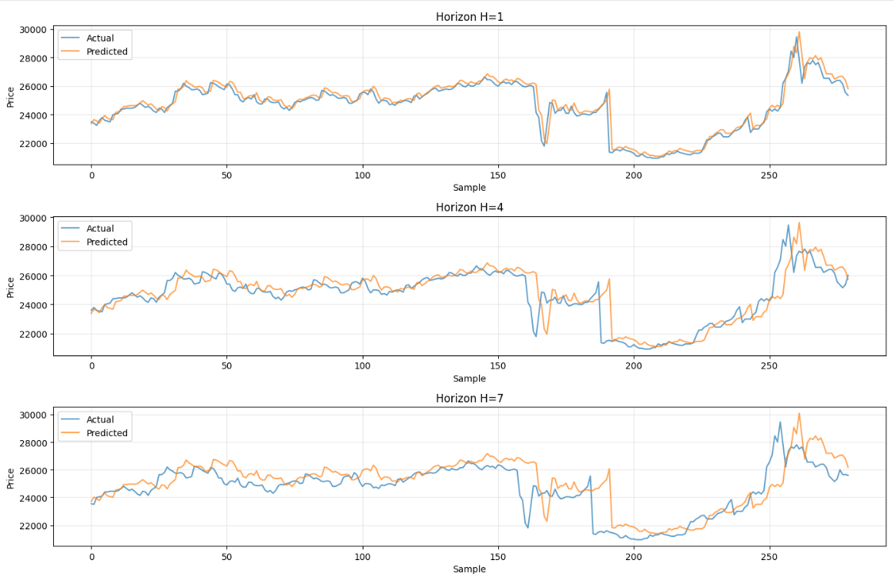

Figure 9: Actual vs predicted closing prices (LSTM_VN_Emb_CrsAtt) across multiple forecasting horizons (H = 1, 4, 7)

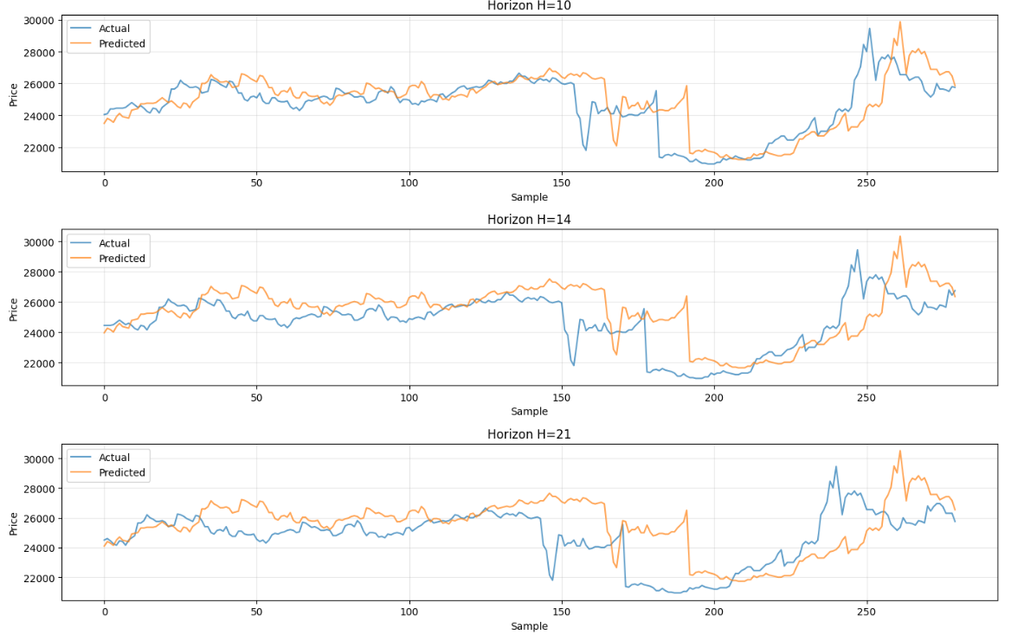

Figure 10: Actual vs predicted closing prices on (LSTM_VN_Emb_CrsAtt) across multiple forecasting horizons (H = 10, 14, 21)

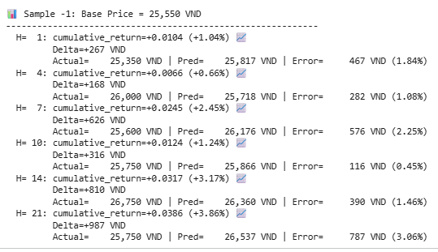

Figure 11: Multi-horizon stock price prediction on a test sample (LSTM_VN_Emb_CrsAtt)

### Concatenate Fusion

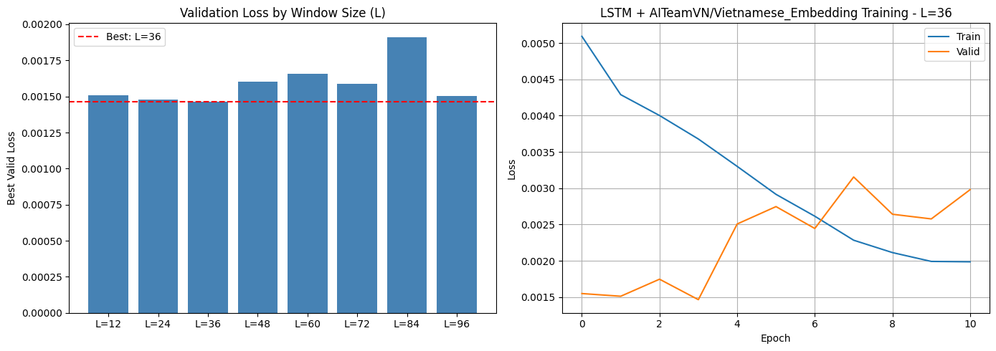

Figure 12: Validation Loss by Window Size and Training Curves of LSTM_VN_Emb_Concat

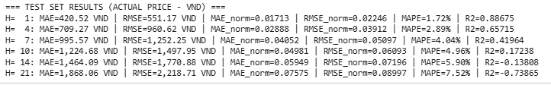

Figure 13: Test Set Results of LSTM_VN_Emb_Concat

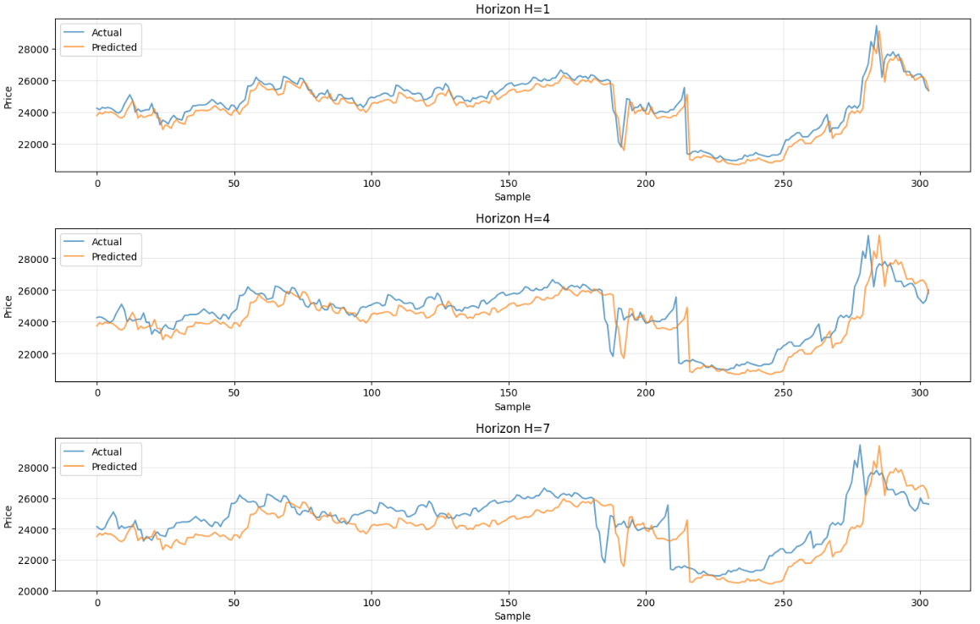

Figure 14: Actual vs predicted closing prices (LSTM_VN_Emb_Concat) across multiple forecasting horizons (H = 1, 4, 7)

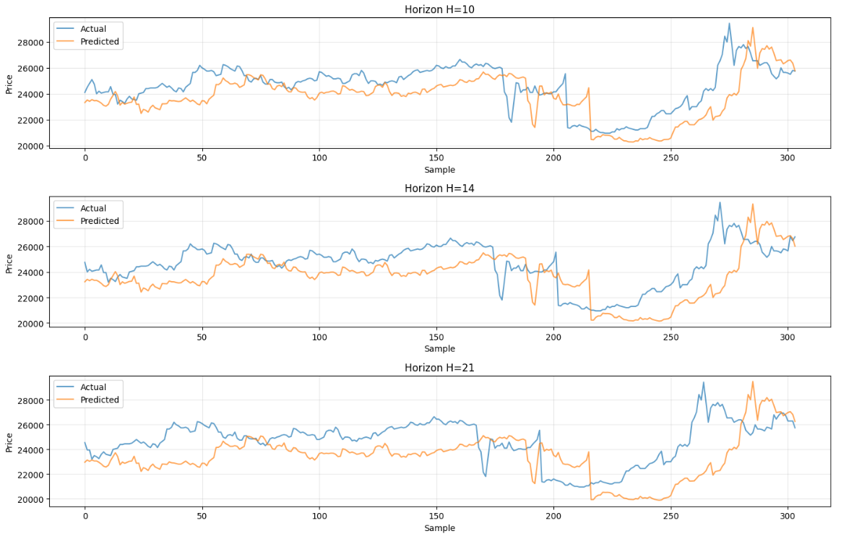

Figure 15: Actual vs predicted closing prices (LSTM_VN_Emb_Concat) across multiple forecasting horizons (H = 10, 14, 21)

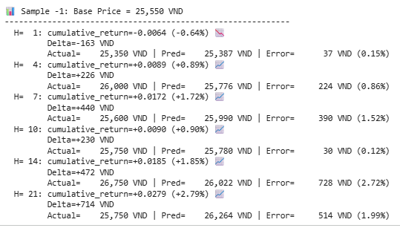

Figure 16: Multi-horizon stock price prediction on a test sample (LSTM_VN_Emb_ConCat)

# LSTM + Vietnamese Document Embedding

## Results

### Cross-Attention

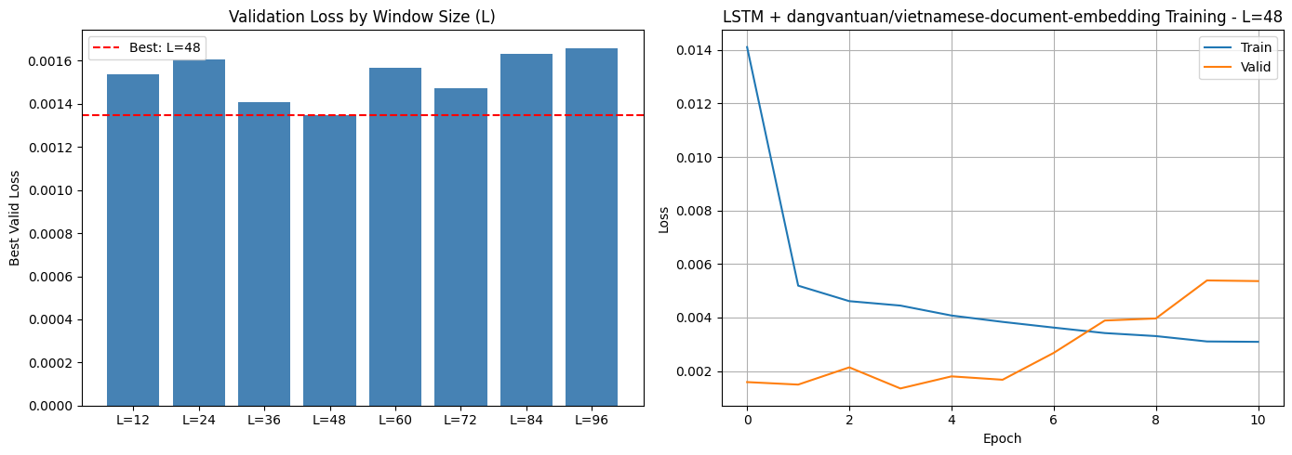

Figure 17: Validation Loss by Window Size and Training Curves of LSTM_VN_Doc_Emb_CrsAtt

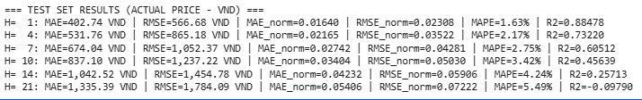

Figure 18: Test Set Results of LSTM_VN_Doc_Emb_CrsAtt

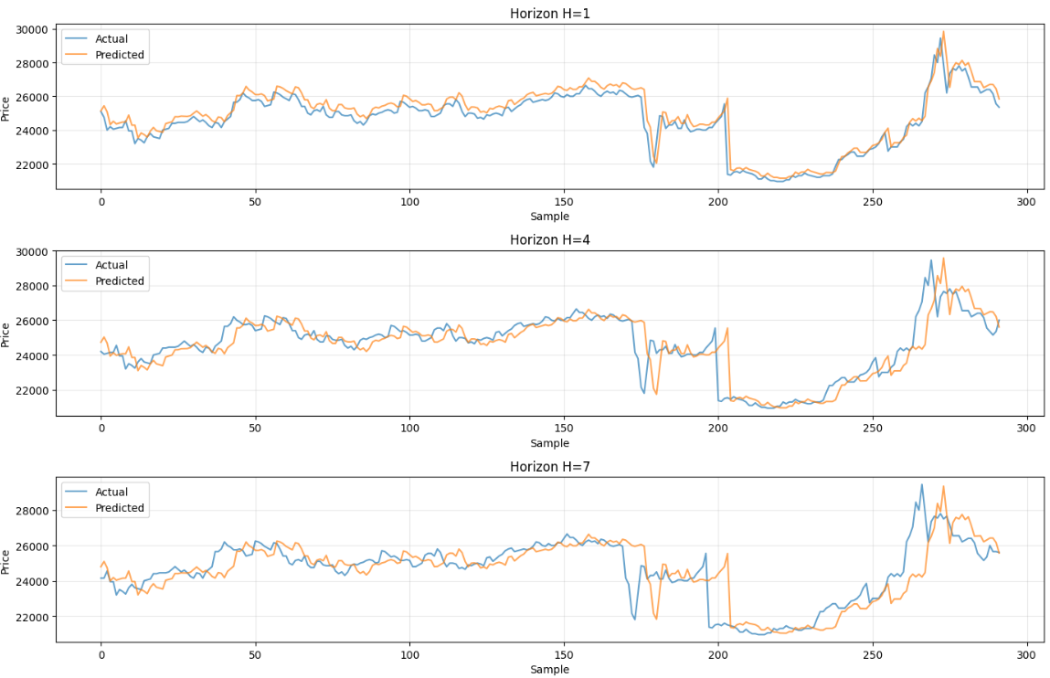

Figure 19: Actual vs predicted closing prices (LSTM_VN_Emb_Doc_CrsAtt) across multiple forecasting horizons (H = 1, 4, 7)

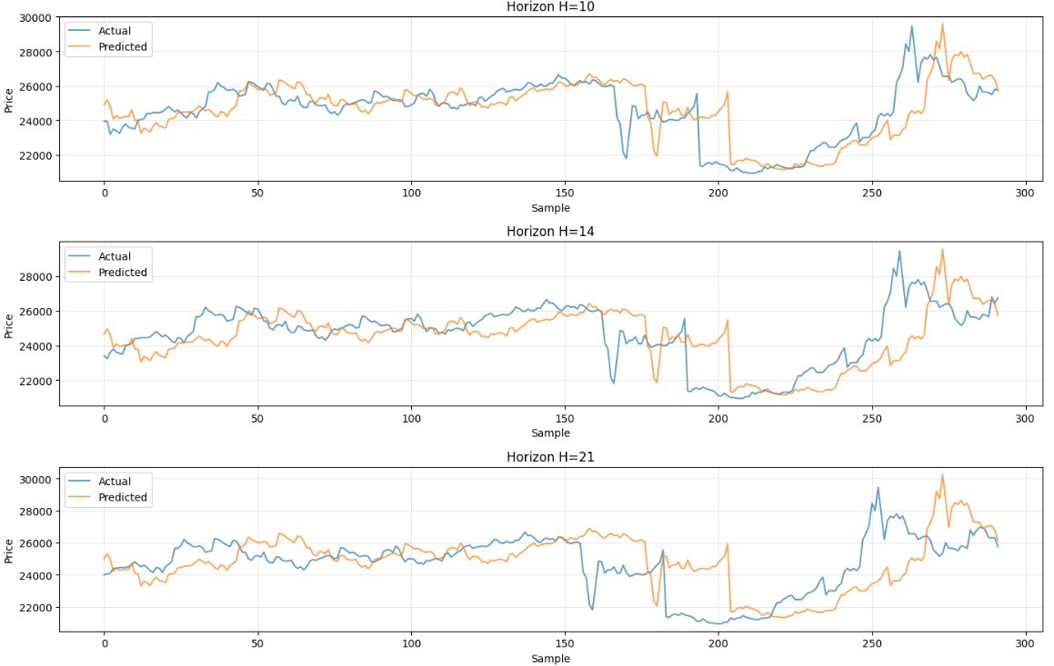

Figure 20: Actual vs predicted closing prices (LSTM_VN_Emb_Doc_CrsAtt) across multiple forecasting horizons (H=10,14,21)

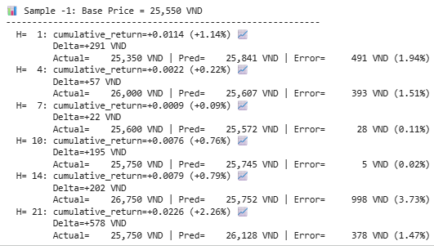

Figure 21: Multi-horizon stock price prediction on a test sample (LSTM_VN_Doc_Emb_CrsAtt)

### Concatenate Fusion

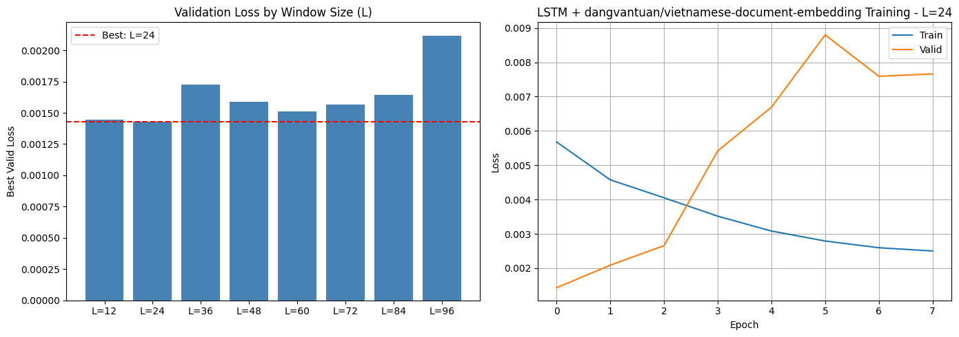

Figure 22: Validation Loss by Window Size and Training Curves of LSTM_VN_Doc_Emb_Concat

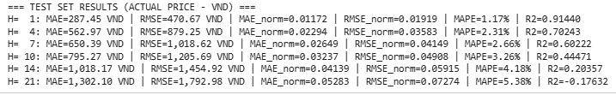

Figure 23: Test Set Results of LSTM_VN_Doc_Emb_Concat

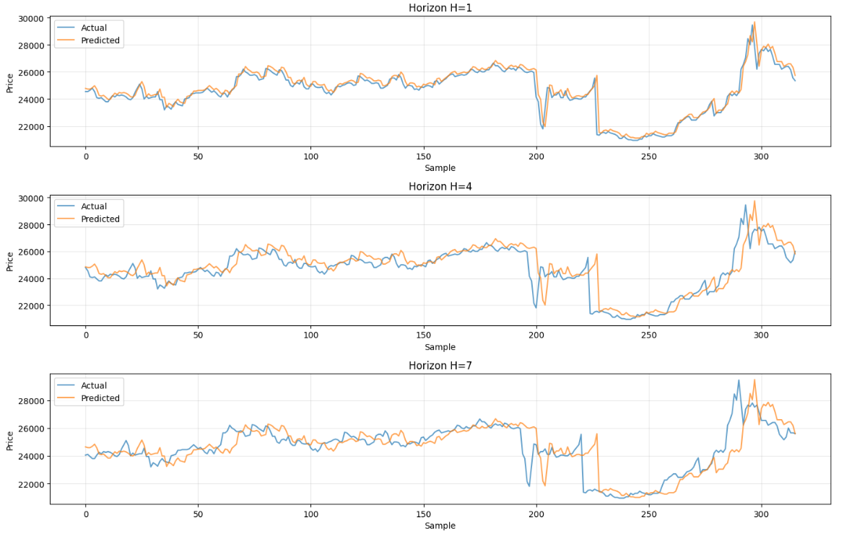

Figure 24: Actual vs predicted closing prices (LSTM_VN_Emb_Doc_Concat) across multiple forecasting horizons (H = 1, 4, 7)

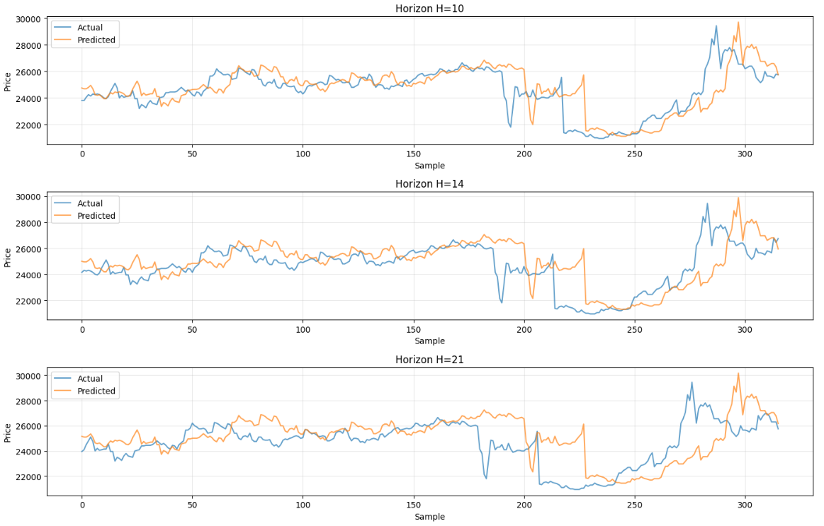

Figure 25: Actual vs predicted closing prices (LSTM_VN_Emb_Doc_Concat) across multiple forecasting horizons (H=10,14,21)

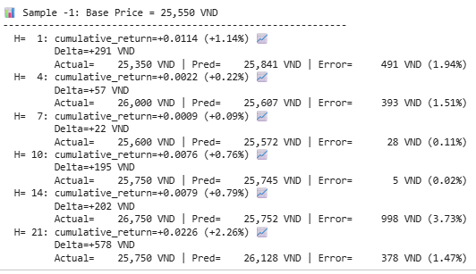

Figure 26: Multi-horizon stock price prediction on a test sample (LSTM_VN_Doc_Emb_Concat)

# PatchTST + Vietnamese Embedding

## Results

### Cross-Attention

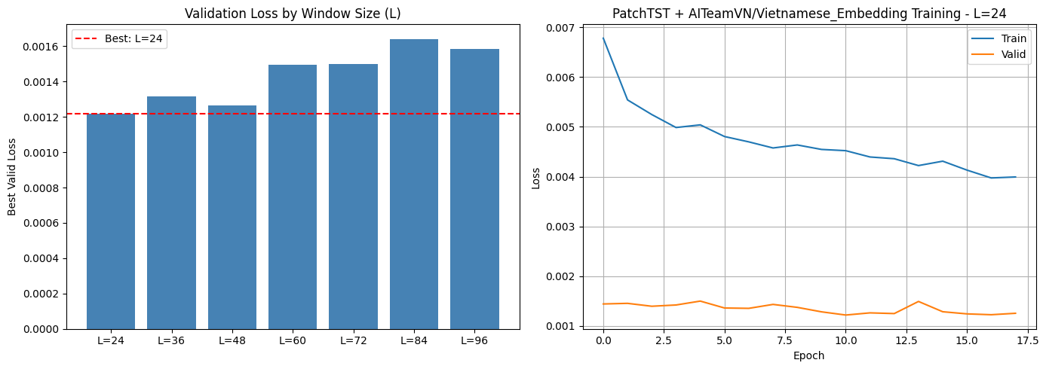

Figure 27: Validation Loss by Window Size and Training Curves of PatchTST_VN_Emb_CrsAtt

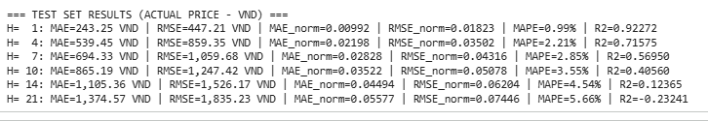

Figure 28: Test Set Results of PatchTST_VN_Emb_CrsAtt

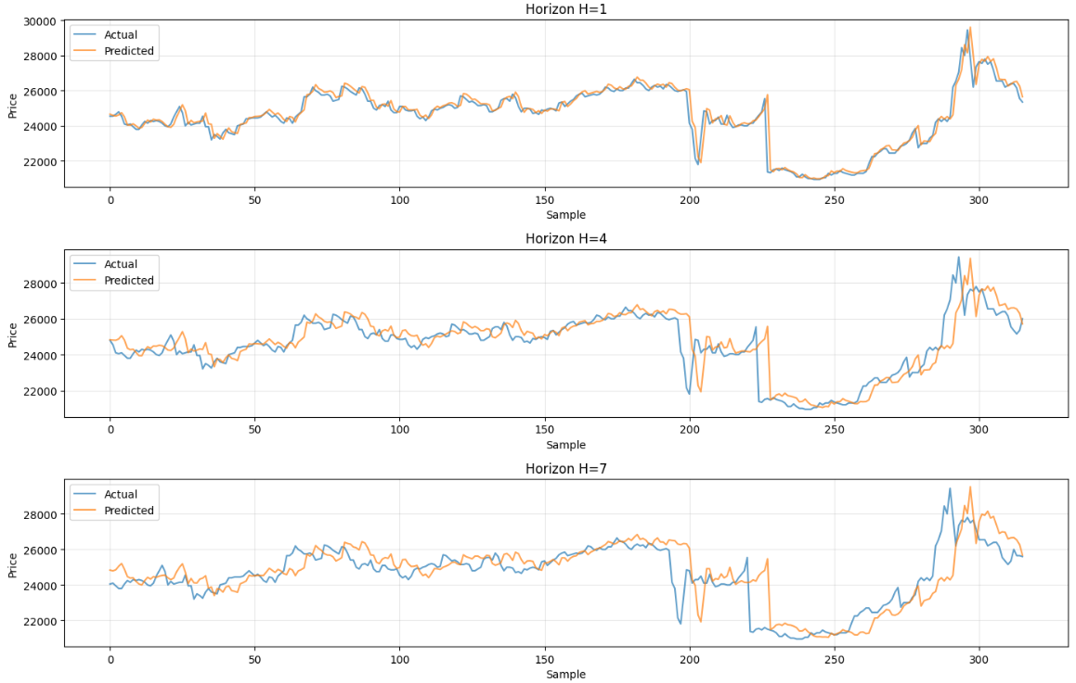

Figure 29: Actual vs predicted closing prices (PatchTST_VN_Emb_CrsAtt) across multiple forecasting horizons (H=1,4,7)

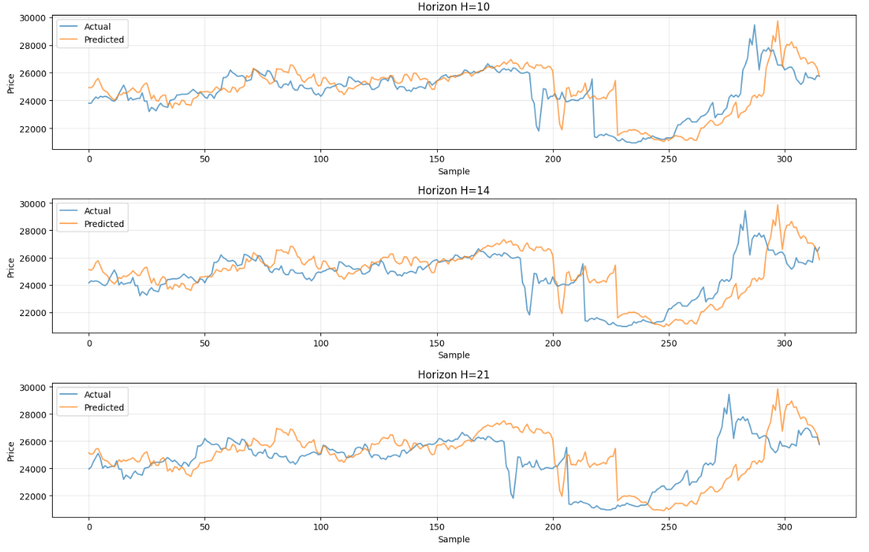

Figure 30: Actual vs predicted closing prices (PatchTST_VN_Emb_CrsAtt) across multiple forecasting horizons (H=10,14,21)

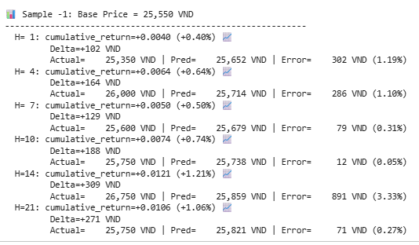

Figure 31: Multi-horizon stock price prediction on a test sample (PatchTST_VN_Emb_CrsAtt)

### Concatenate Fusion

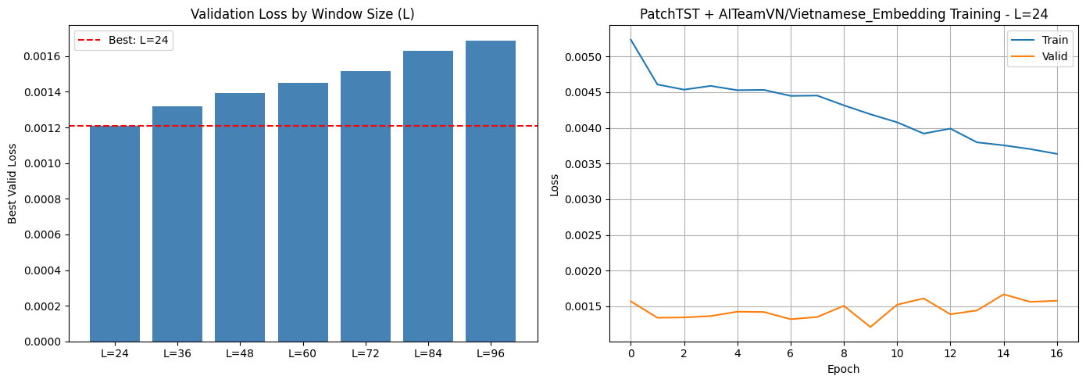

Figure 32: Validation Loss by Window Size and Training Curves of PatchTST_VN_Emb_Concat

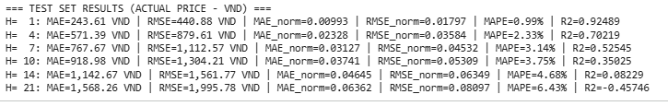

Figure 33: Test Set Results of PatchTST_VN_Emb_Concat

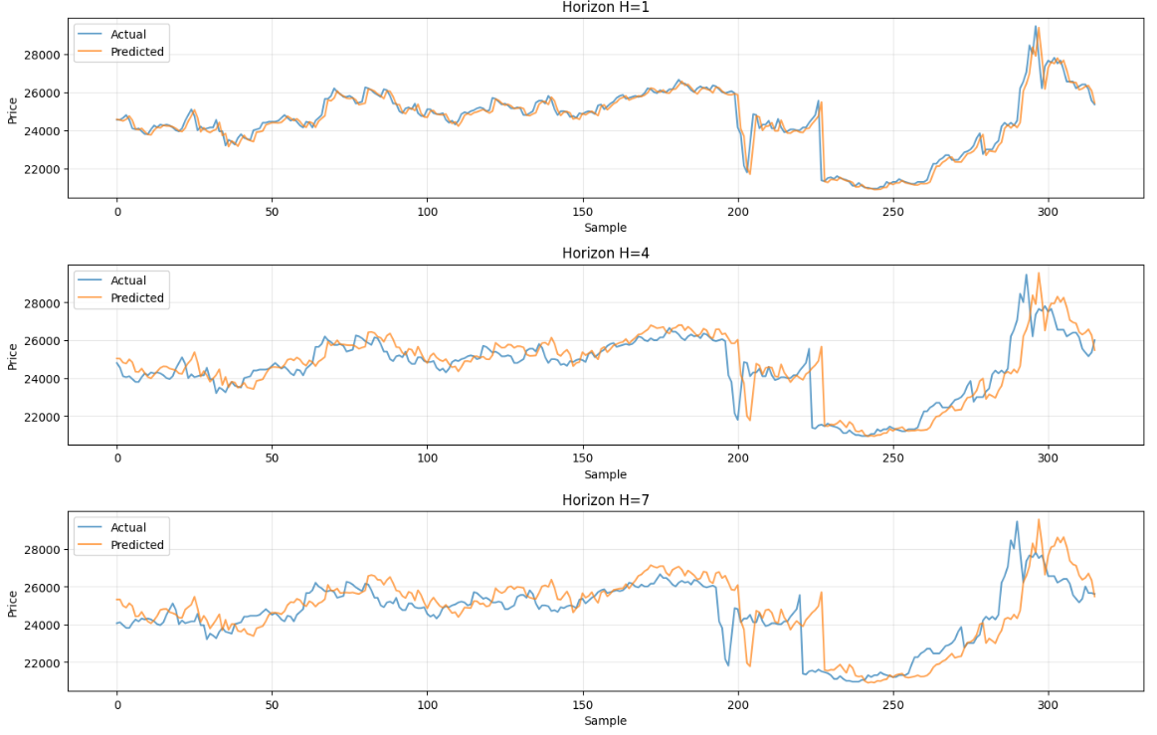

Figure 34: Actual vs predicted closing prices (PatchTST_VN_Emb_Concat) across multiple forecasting horizons (H=1,4,7)

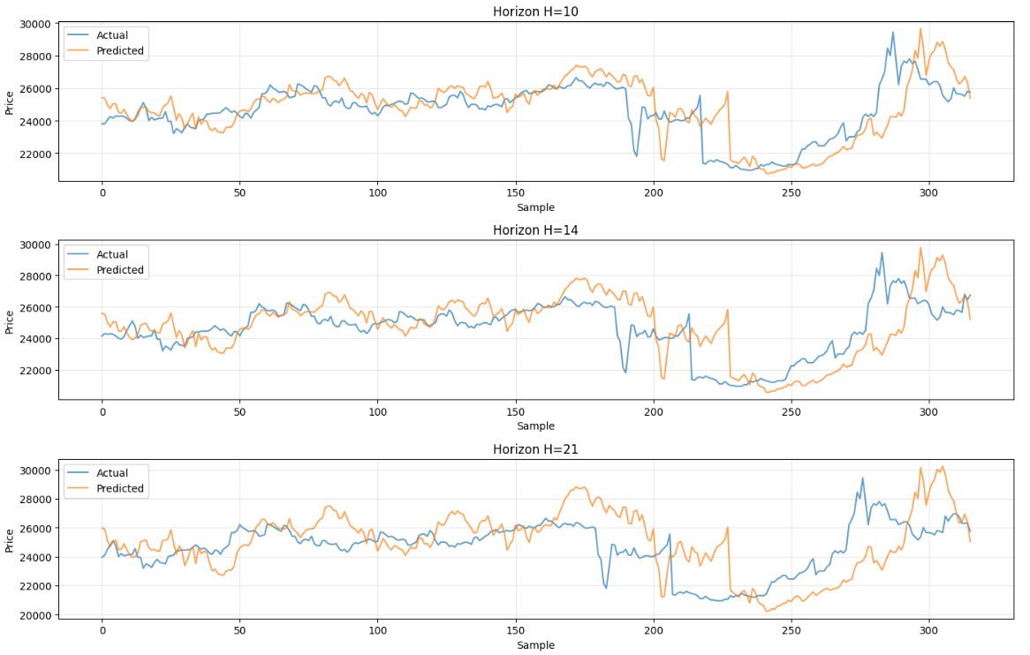

Figure 35: Actual vs predicted closing prices (PatchTST_VN_Emb_Concat) across multiple forecasting horizons (H=10,14,21)

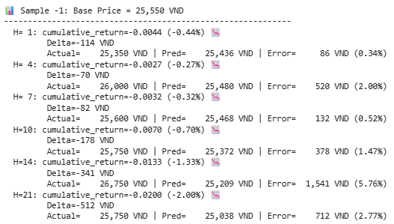

Figure 36: Multi-horizon stock price prediction on a test sample (PatchTST_VN_Emb_Concat)

# PatchTST + Vietnamese Document Embedding

## Results

### Cross-Attention

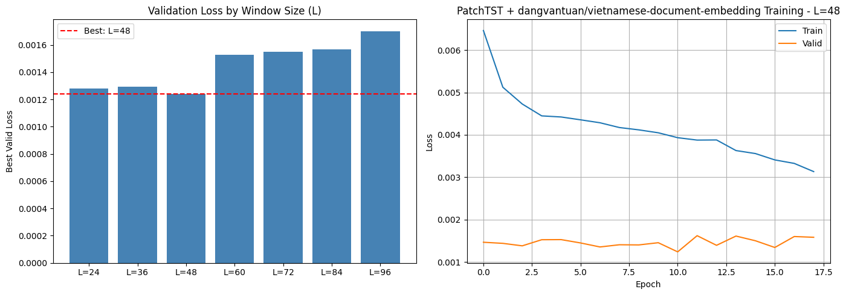

Figure 37: Validation Loss by Window Size and Training Curves of PatchTST_VN_Doc_Emb_CrsAtt

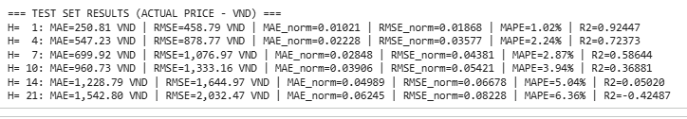

Figure 38: Test Set Results of PatchTST_VN_Doc_Emb_CrsAtt

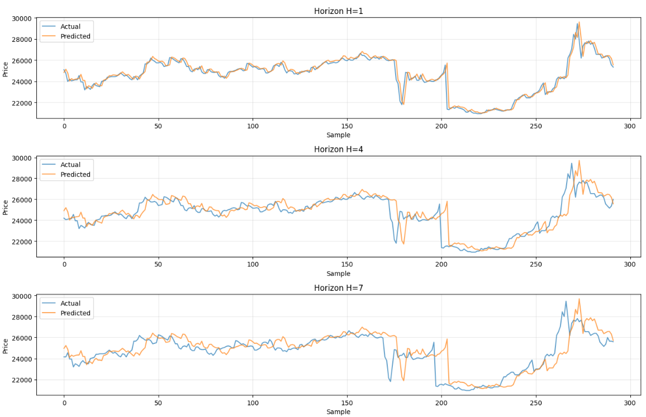

Figure 39: Actual vs predicted closing prices (PatchTST_VN_Doc_Emb_CrsAtt) across multiple forecasting horizons (H=1,4,7)

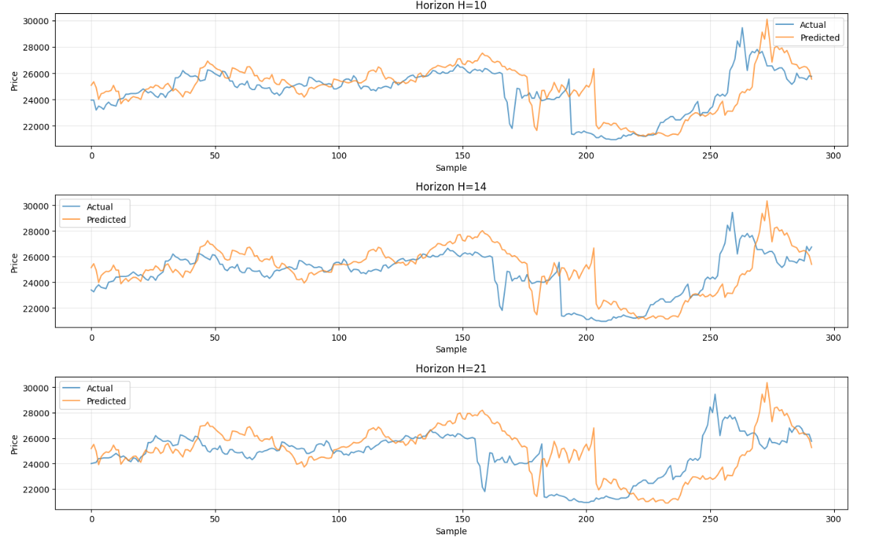

Figure 40: Actual vs predicted closing prices (PatchTST_VN_Doc_Emb_CrsAtt) across multiple forecasting horizons (H=10,14,21)

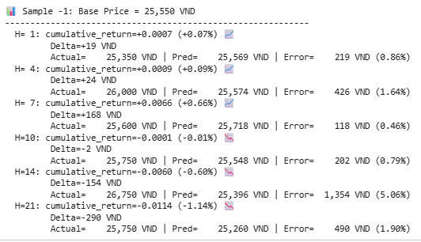

Figure 41: Multi-horizon stock price prediction on a test sample (PatchTST_VN_Doc_Emb_CrsAtt)

### Concatenate Fusion

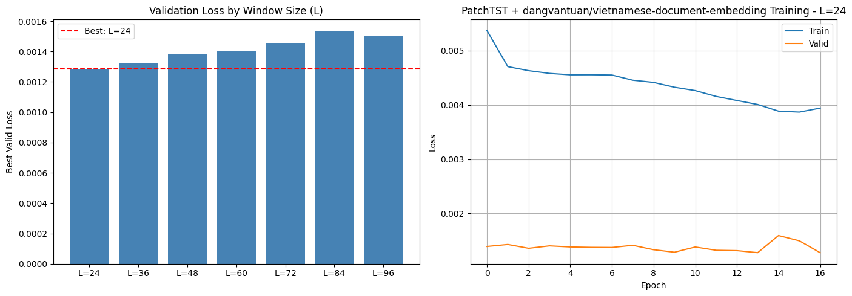

Figure 42: Validation Loss by Window Size and Training Curves of PatchTST_VN_Doc_Emb_Concat

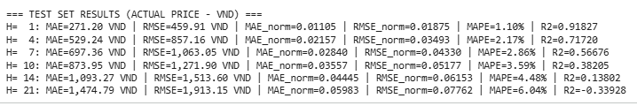

Figure 43: Test Set Results of PatchTST_VN_Doc_Emb_Concat

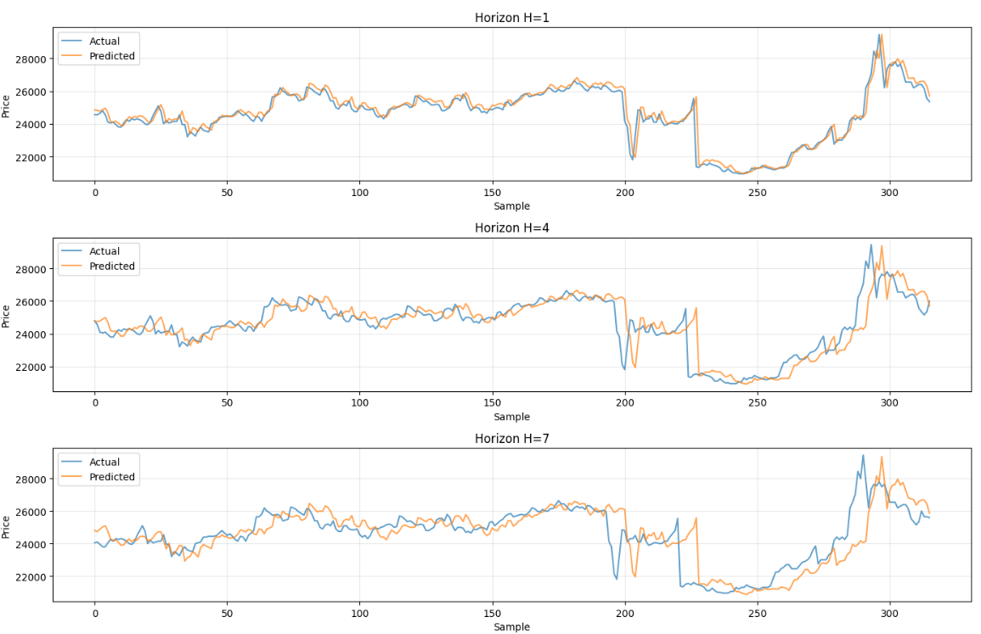

Figure 44: Actual vs predicted closing prices (PatchTST_VN_Doc_Emb_Concat) across multiple forecasting horizons (H=1,4,7)

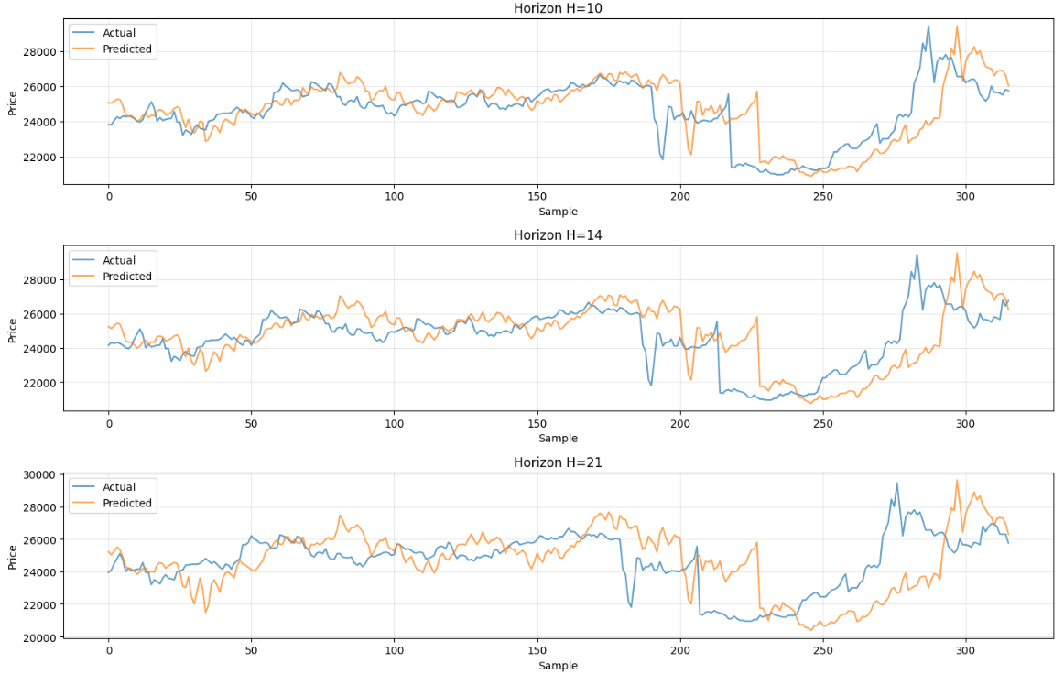

Figure 45: Actual vs predicted closing prices (PatchTST_VN_Doc_Emb_Concat) across multiple forecasting horizons (H=10,14,21)

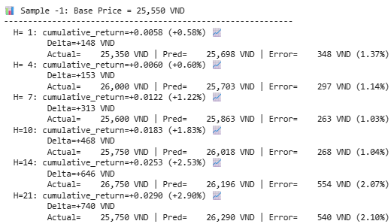

Figure 46: Multi-horizon stock price prediction on a test sample (PatchTST_VN_Doc_Emb_Concat)

# iTransformer + Vietnamese Embedding

## Results

### Cross-Attention

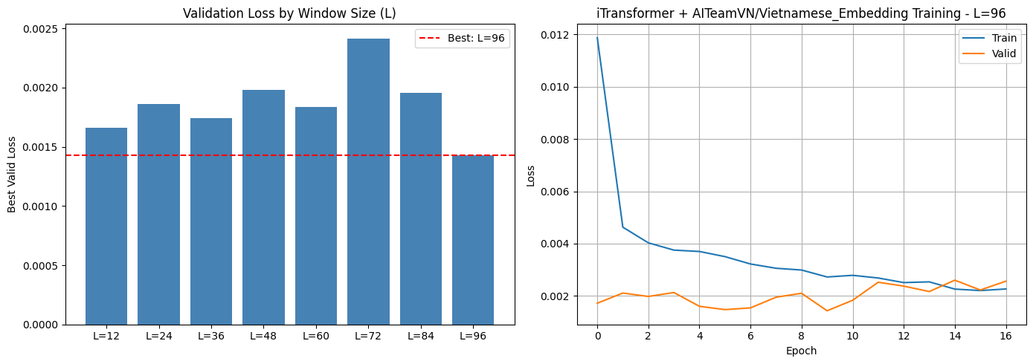

Figure 47: Validation Loss by Window Size and Training Curves of iTransformer_VN_Emb_CrsAtt

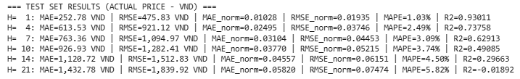

Figure 48: Test Set Results of iTransformer_VN_Emb_CrsAtt

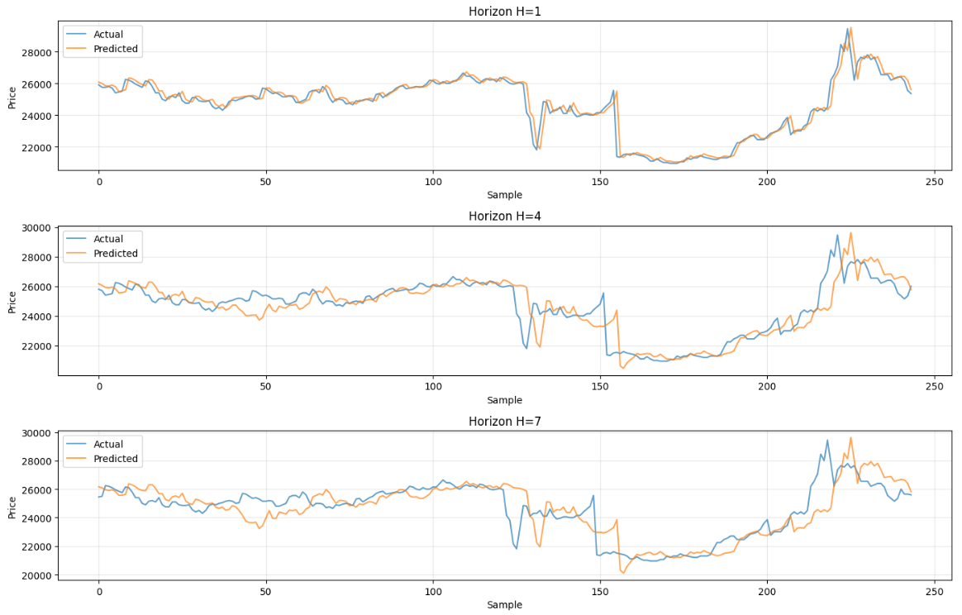

Figure 49: Actual vs predicted closing prices (iTransformer_VN_Emb_CrsAtt) across multiple forecasting horizons (H=1,4,7)

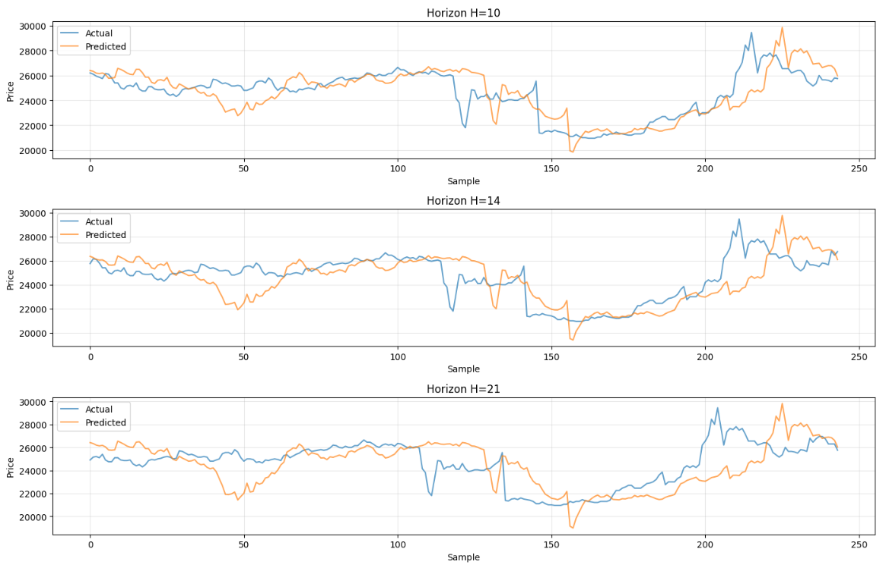

Figure 50: Actual vs predicted closing prices (iTransformer_VN_Emb_CrsAtt) across multiple forecasting horizons (H=10,14,21)

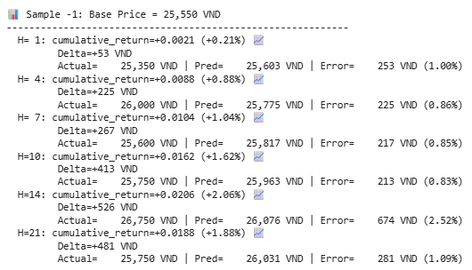

Figure 51: Multi-horizon stock price prediction on a test sample (iTransformer_VN_Emb_CrsAtt)

### Concatenate Fusion

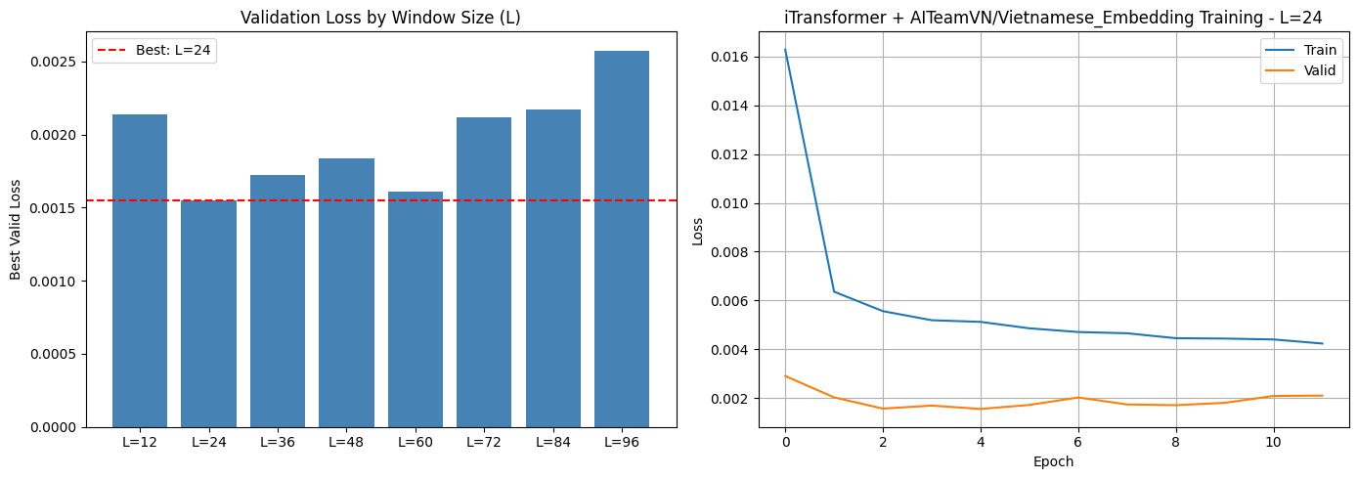

Figure 52: Validation Loss by Window Size and Training Curves of iTransformer_VN_Emb_Concat

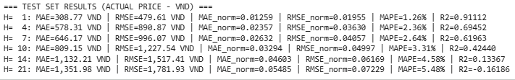

Figure 53: Test Set Results of iTransformer_VN_Emb_Concat

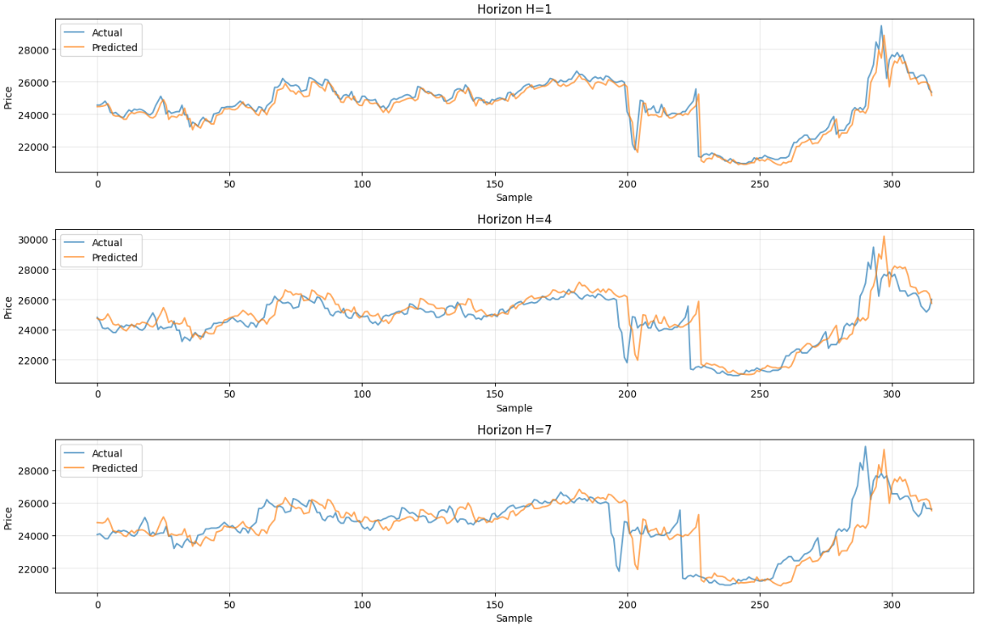

Figure 54: Actual vs predicted closing prices (iTransformer_VN_Emb_Concat) across multiple forecasting horizons (H=1,4,7)

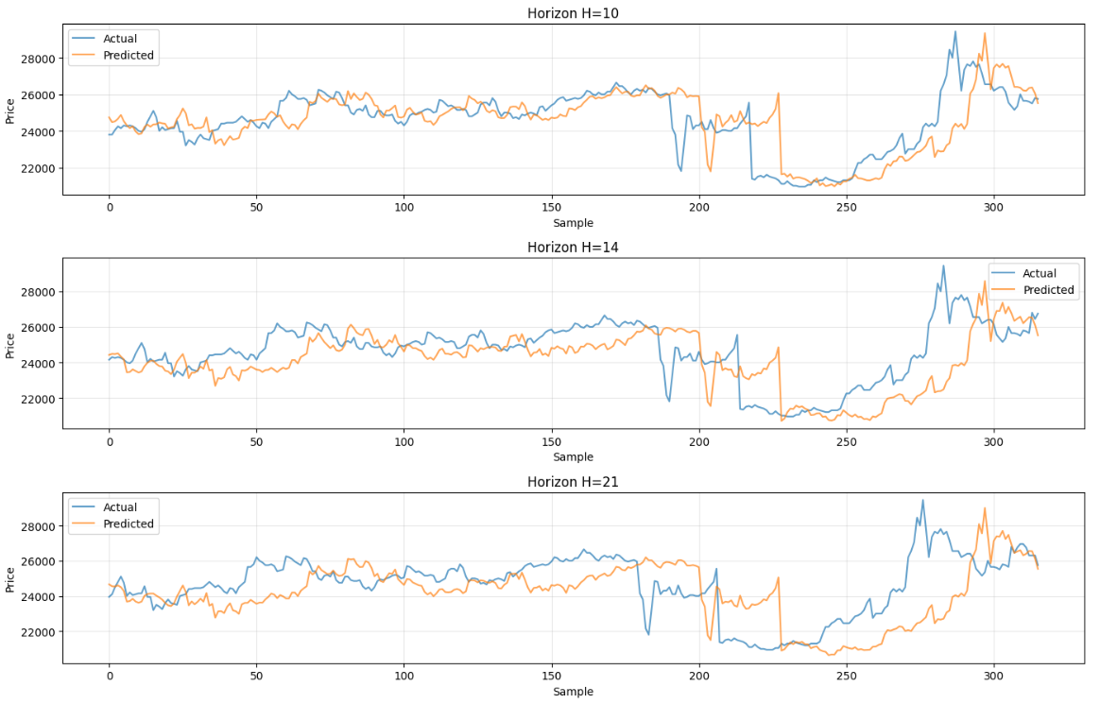

Figure 55: Actual vs predicted closing prices (iTransformer_VN_Emb_Concat) across multiple forecasting horizons (H=10,14,21)

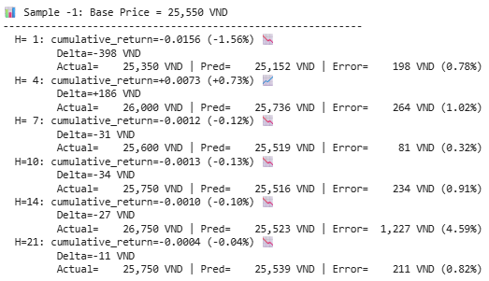

Figure 56: Multi-horizon stock price prediction on a test sample (iTransformer_VN_Emb_Concat)

# iTransformer + Vietnamese Document Embedding

## Results

### Cross-Attention

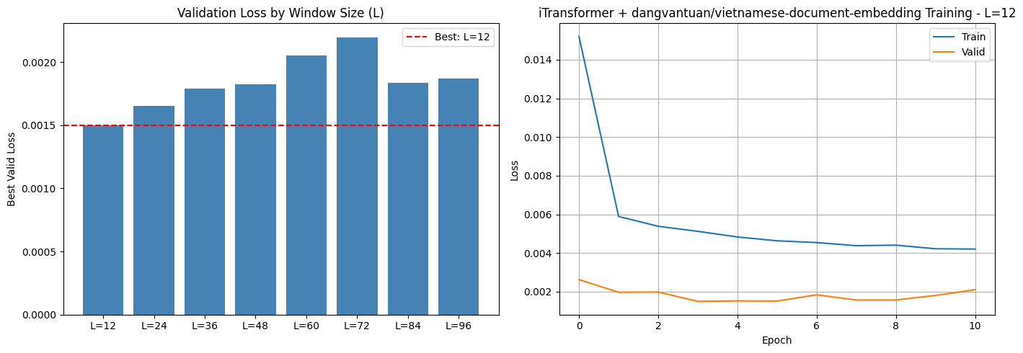

Figure 57: Validation Loss by Window Size and Training Curves of iTransformer_VN_Doc_Emb_CrsAtt

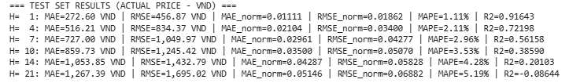

Figure 58: Test Set Results of iTransformer_VN_Doc_Emb_CrsAtt

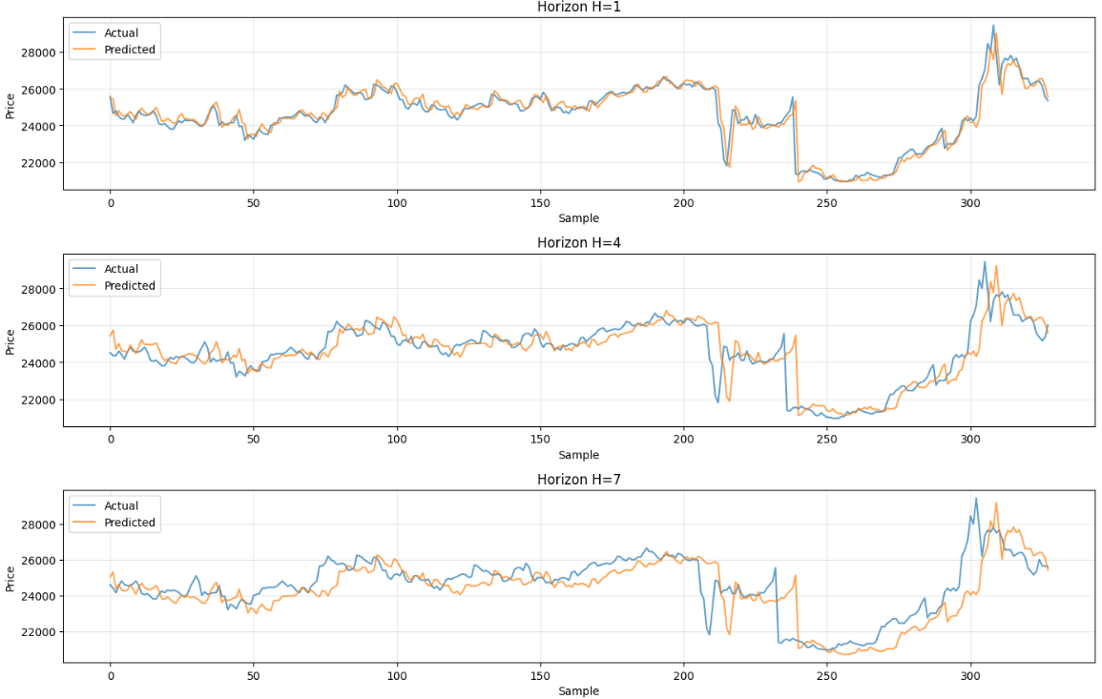

Figure 59: Actual vs predicted closing prices (iTransformer_VN_Doc_Emb_CrsAtt) across multiple forecasting horizons (H=1,4,7)

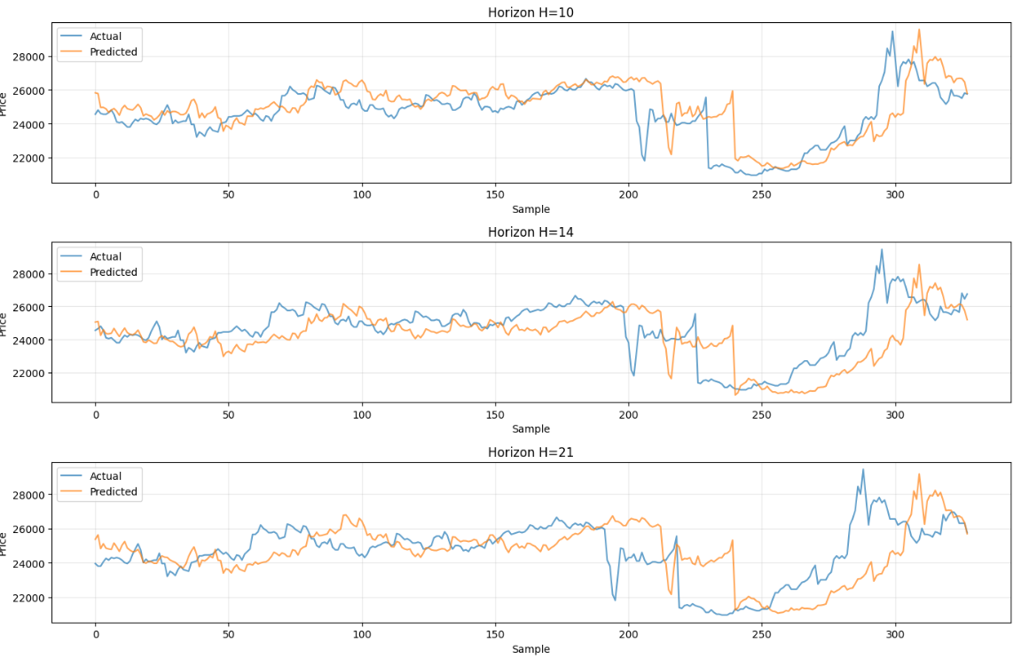

Figure 60: Actual vs predicted closing prices (iTransformer_VN_Doc_Emb_CrsAtt) across multiple forecasting horizons (H=10,14,21)

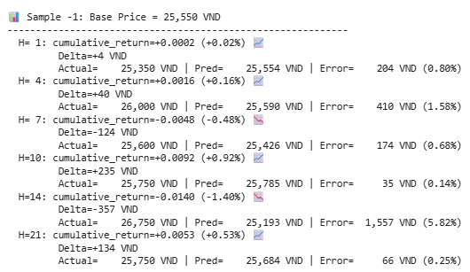

Figure 61: Multi-horizon stock price prediction on a test sample (iTransformer_VN_Doc_Emb_CrsAtt)

### Concatenate Fusion

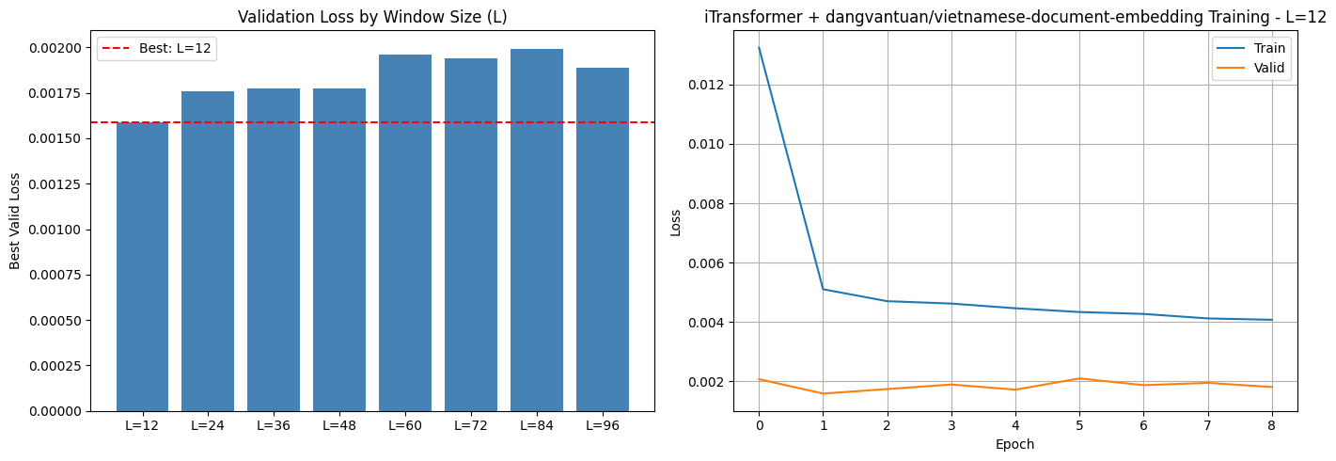

Figure 62: Validation Loss by Window Size and Training Curves of iTransformer_VN_Doc_Emb_Concat

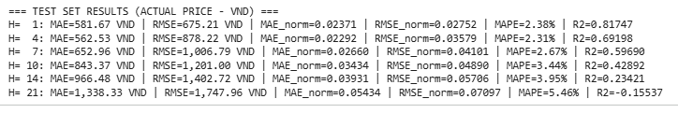

Figure 63: Test Set Results of iTransformer_VN_Doc_Emb_Concat

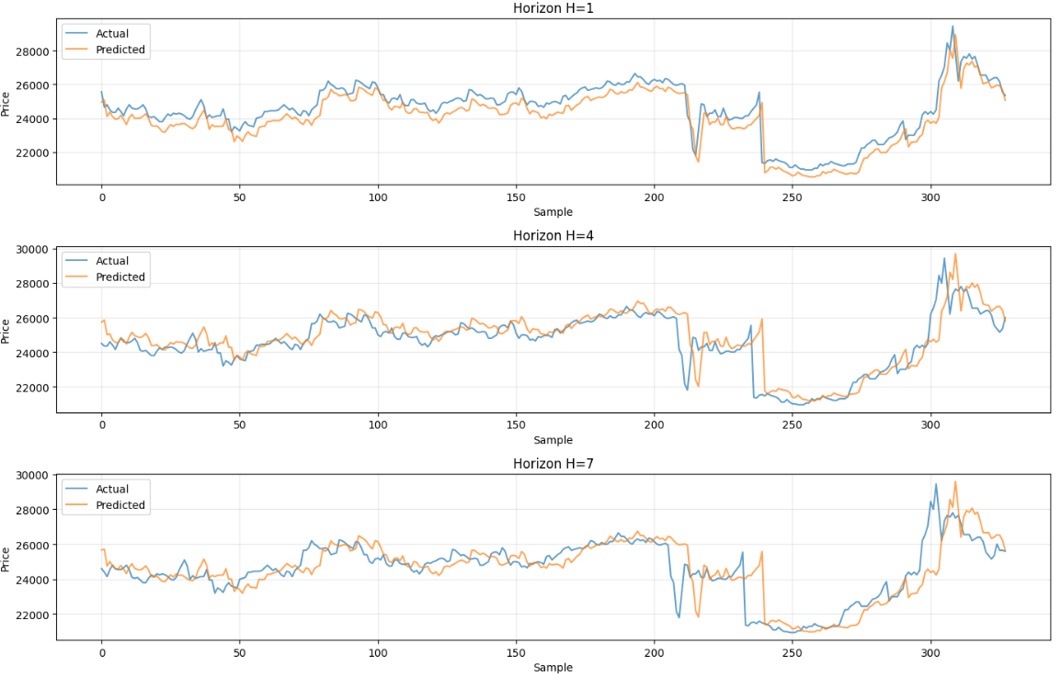

Figure 64: Actual vs predicted closing prices (iTransformer_VN_Doc_Emb_Concat) across multiple forecasting horizons (H=1,4,7)

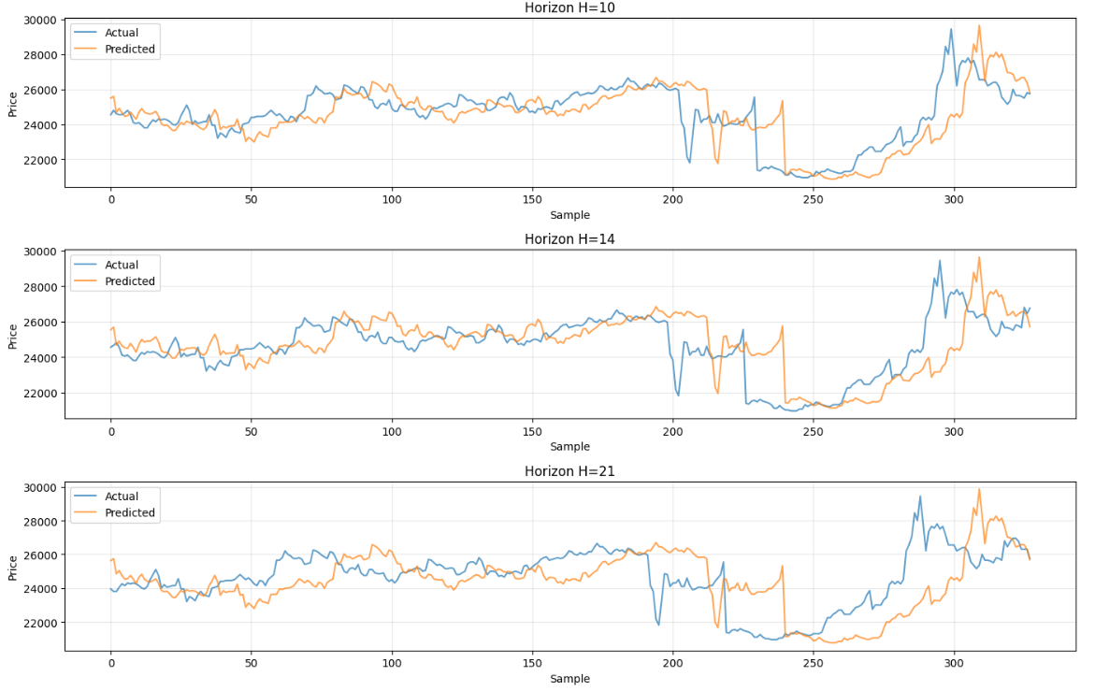

Figure 65: Actual vs predicted closing prices (iTransformer_VN_Doc_Emb_Concat) across multiple forecasting horizons (H=10,14,21)

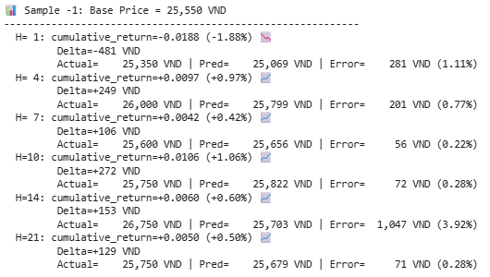

Figure 66: Multi-horizon stock price prediction on a test sample (iTransformer_VN_Doc_Emb_Concat)